**Toynbee School Year 7 Uniform 2022**

**Girls’ uniform:**

* Plain white shirt. (short sleeve in the summer if preferred)
* [School Tie](https://www.skoolkit.co.uk/school-uniform/114/view/2806) – clip-on. (available from the school or Skoolkit)
* [Plain Black Girls Blazer with embroidered badge](https://www.skoolkit.co.uk/school-uniform/114/view/7201) (available from Skoolkit) or Plain Black Blazer with the school badge to be purchased separately (available from Toynbee Reception or Skoolkit) and sewn onto the left breast pocket.
* [Grey Tartan Box Pleat Skirt](https://www.skoolkit.co.uk/school-uniform/114/view/6185) (available from Skoolkit) or black trousers (not leggings, jeans or jeggings – not tight material). No other style of skirt is acceptable.
* Black Cardigan/v neck jumper. (plain acrylic/cotton/wool – no design or logo)
* Black or brown shoes (leather/vinyl) – no canvas pumps, trainers or boots.
* Black or grey tights, woollen tights or ankle socks.
* Suitable coat.

**Boys’ uniform:**

* Plain white shirt. (short sleeve in summer if preferred)
* [School Tie](https://www.skoolkit.co.uk/school-uniform/114/view/2806) – clip-on. (available from the school or Skoolkit)
* [Plain Black Boys Blazer with embroidered badge](https://www.skoolkit.co.uk/school-uniform/114/view/7200) (available from Skoolkit) or Plain Black Blazer with the school badge to be purchased separately (available from Toynbee Reception or Skoolkit) and sewn onto the left breast pocket.
* Black school trousers. (not leggings, jeans or jeggings – not tight material)
* Black Jumper – v neck. (plain acrylic/cotton/wool – no design or logo)
* Black or brown shoes. (leather/vinyl) – no canvas shoes, trainers, boots or pumps
* Black or grey socks.
* Suitable coat.

**Where to obtain the uniform:**

Toynbee uniform is available from [SkoolKit](https://www.skoolkit.co.uk/school-uniform/114): <https://www.skoolkit.co.uk/school-uniform/114>.

Certain other items (eg Shirts, Jumper, Trousers) can be brought from a retail outlet of your choice (eg. Marks and Spencer, John Lewis, Asda and Tesco or alternatively from Skoolkit). Please ensure that you place your order well in advance of the school term starting in September.

**Ties:**

You will be able to buy the school tie from the school or Skoolkit. Stock will be available in school during term time. All pupils wear a black and grey striped tie.

**Badges:**

If the Blazer does not have the Toynbee embroidered badge, these can be purchased from the school reception. They should be hand sewn onto the blazer, positioned at the left breast pocket.

Shirts must be tucked in at all times and school blazers to be worn throughout the year.

**Standards of appearance:**

* Make-up is discouraged. Jewellery, false nails, coloured nail varnish and false eyelashes are not permitted in school.
* Girls and boys with pierced ears should, for reasons of safety, wear stud earrings and only one in each ear. No visible body or facial piercings are allowed, this includes spikes and expanders. This is not an exclusive list.
* Extreme hairstyles must be avoided:
  + No extreme haircuts
  + No cuts shorter than a grade 2
  + No coloured hair, eg. natural colour only
  + No tramlines, razor cuts, beading or non-natural hair or coloured braiding
* Trainers are not to be worn as normal footwear.
* Hoodies and coats or garments with slogans are not allowed.
* There should be no variation of this uniform and coats should not be worn in school.

**This is not an exclusive list.  Final judgement will always rest with the Senior Leadership Team and Guidance Managers.**

**Girls’ PE Uniform:**

* [Plain Black PE Polo Shirt](https://www.skoolkit.co.uk/school-uniform/114/view/5997) available from Skoolkit or plain black T-shirt.
* [Reversible Rugby Shirt](https://www.skoolkit.co.uk/school-uniform/114/view/300) with red band from the school’s supplier, or a plain black sweatshirt. (no hoods)
* Black shorts.
* Black or white trainers. (no plimsolls)
* Long red socks or short plain white sports socks. (depending on the activity)
* Football boots (metal studs are not allowed on the synthetic pitch) and shin guards.

**Boys’ PE Uniform**

* [Plain Black PE Polo Shirt](https://www.skoolkit.co.uk/school-uniform/114/view/5997) available from Skoolkit or plain black T-shirt.
* [Reversible Rugby Shirt](https://www.skoolkit.co.uk/school-uniform/114/view/300) with red band from the school’s supplier, or a plain black sweatshirt. (no hoods)
* Black shorts.
* Black or white trainers. (no plimsolls)
* Long red socks or short plain white sports socks. (depending on the activity)
* Football boots (metal studs are not allowed on the synthetic pitch) and shin guards.
* Boxer shorts must not be worn during PE lessons; tighter fitting underpants should be worn.

A towel for use after taking a shower, and changes of underwear and socks, are essential. All PE kit should be taken home after use for washing. Pupils should be reminded to bring it to school on the appropriate days and should not wear their day clothes for PE. A gum-shield is recommended for hockey (boys and girls) and rugby (boys) but is not compulsory.

**Uniform Examples**

**Girls’ Uniform:**

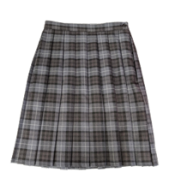[**Toynbee Girls Blazer**](https://www.skoolkit.co.uk/school-uniform/114/view/7201) [**School Tie**](https://www.skoolkit.co.uk/school-uniform/114/view/2806)[**Grey Tartan Box Pleat Skirt**](https://www.skoolkit.co.uk/school-uniform/114/view/6185)

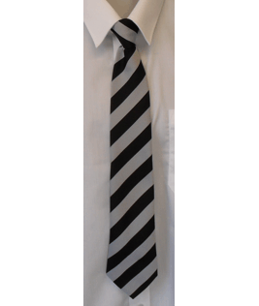

**Boys’ Uniform:**

[**Toynbee Boys Blazer**](https://www.skoolkit.co.uk/school-uniform/114/view/7200)[**School Tie**](https://www.skoolkit.co.uk/school-uniform/114/view/2806) **Plain Black Trousers**

**Boys shoe styles – acceptable**

**Girls shoe styles - acceptable**

**PE Uniform:**

[**PE Polo Shirt**](https://www.skoolkit.co.uk/school-uniform/114/view/5997)[**Reversible Rugby Shirt**](https://www.skoolkit.co.uk/school-uniform/114/view/300)[**Plain Black Shorts**](https://www.skoolkit.co.uk/school-uniform/114/view/1665)

**The following styles of uniform are not acceptable:**

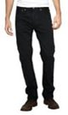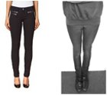**Unacceptable girls’ trousers Unacceptable boys’ trousers**

**Unacceptable shoes:**

[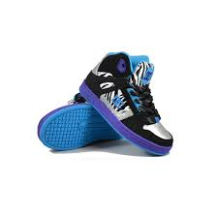](http://www.google.co.uk/imgres?q=black%20shoes%20for%20girls&safe=active&rlz=1R2AURU_enGB501&biw=1627&bih=849&tbm=isch&tbnid=sgTgQ5wXRW2KPM:&imgrefurl=http://www.annscottage.com/shop-by-brand/dc-shoes/girls-dc-shoes-rebound-shoe-black-blue/c-302676abgw12i-blk-zeb/&docid=JKvn5sJ2kNGQ6M&imgurl=http://www.annscottage.com/cpimages/product_zoom/152777.jpg&w=1200&h=1200&ei=DBIwU_jNJpKv7Ab21oGgBg&zoom=1&ved=0CIcDEIQcMGM&iact=rc&dur=509&page=3&start=71&ndsp=39)[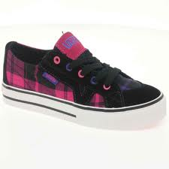](http://www.google.co.uk/imgres?q=black%20shoes%20for%20girls&safe=active&rlz=1R2AURU_enGB501&biw=1627&bih=849&tbm=isch&tbnid=MFBOXt794TNAwM:&imgrefurl=http://www.charlesclinkard.co.uk/girls-c23/canvas-c30/vans-vans-tory-junior-black-plaid-canvas-lace-up-girls-shoes-p9379&docid=6Qy8U7Re9dIV0M&imgurl=http://www.charlesclinkard.co.uk/images/products/zoom/1328193748-40496500.jpg&w=1000&h=1000&ei=DBIwU_jNJpKv7Ab21oGgBg&zoom=1&ved=0CPoBEIQcMDQ&iact=rc&dur=36&page=2&start=31&ndsp=40)[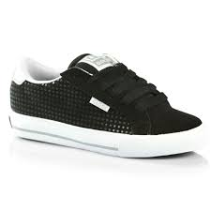](http://www.google.co.uk/imgres?q=black%20shoes%20for%20girls&safe=active&rlz=1R2AURU_enGB501&biw=1627&bih=849&tbm=isch&tbnid=3OX86tm83lcm5M:&imgrefurl=http://www.surfdome.com/globe_shoes_-_globe_chalice_girls_shoes_-_black/silver-8834&docid=4h9yoePcWusoiM&imgurl=http://asset3.surfcdn.com/globe-shoes-globe-chalice-girls-shoes-black-silver.jpg?w%3D1200%26h%3D1200%26q%3D80%26o%3DDLH@GXekg6vbK4r$Kw4TgiODitsj%26V%3D5wmI&w=1200&h=1200&ei=DBIwU_jNJpKv7Ab21oGgBg&zoom=1&ved=0CIACEIQcMDY&iact=rc&dur=175&page=2&start=31&ndsp=40)[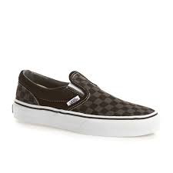](http://www.google.co.uk/imgres?q=black%20shoes%20for%20girls&start=330&safe=active&rlz=1R2AURU_enGB501&biw=1627&bih=849&tbm=isch&tbnid=170BQEQAVAjH9M:&imgrefurl=http://www.surfdome.com/Vans_Girls_Shoes-700/23&docid=A0tnps3Zy5BjpM&imgurl=http://asset2.surfcdn.com/vans-shoes-vans-kids-classic-slip-on-shoes-black-pewter.jpg?w%3D1200%26h%3D1200%26q%3D80%26o%3DOAibscM30@BuGXrXg7F9aKWwxvAj%26V%3D68SH&w=1200&h=1200&ei=SBQwU5agL4mBhQfY6IHIBA&zoom=1&ved=0CJwBEIQcMDE4rAI&iact=rc&dur=34&page=10&ndsp=36)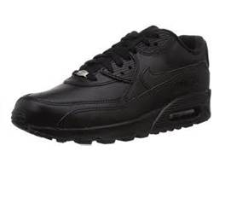[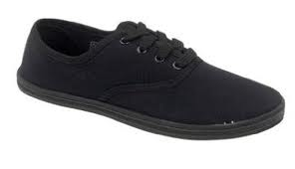](http://www.google.co.uk/imgres?q=plimsolls%20for%20girls&start=70&safe=active&rlz=1R2AURU_enGB501&biw=1627&bih=849&tbm=isch&tbnid=Z5iAbRggDf3zKM:&imgrefurl=http://www.amazon.co.uk/PLIMSOLES-PLIMSOLLS-ESPADRILLES-TRAINERS-CANVAS/dp/B007D3HP96&docid=ioOHALRHoFsYnM&imgurl=http://ecx.images-amazon.com/images/I/31RfldY3ADL._SX395_.jpg&w=395&h=228&ei=bxYwU76SJOWO7Qal8ICoBg&zoom=1&ved=0CBUQhBwwBDhk&iact=rc&dur=37&page=3&ndsp=38)[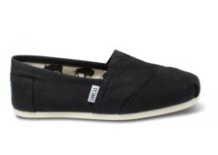](http://www.google.co.uk/url?sa=i&rct=j&q=cloth%20black%20shoes%20for%20girls&source=images&cd=&cad=rja&uact=8&docid=91Vm6aeaNZoCvM&tbnid=vtvBI6y1824hIM:&ved=0CAYQjRw&url=http://www.toms.com/black-canvas-classics-shoes-1/s&ei=SxkwU8D0K4nxhQfepIH4Bg&bvm=bv.62922401,d.ZGU&psig=AFQjCNEiDjlVhtmQ89fEenb8kQjoM386Wg&ust=1395747362335214)[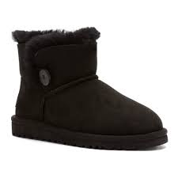](http://www.google.co.uk/imgres?q=ugg%20boots%20for%20girls&start=356&safe=active&rlz=1R2AURU_enGB501&biw=1627&bih=849&tbm=isch&tbnid=IfBxQP-4xQhrAM:&imgrefurl=http://www.bootsboxing.com/girls-ugg-k-mini-bailey-button-black-boots-p-8.html&docid=3wPQjAWn-Mrz4M&imgurl=http://www.bootsboxing.com/images/ugg/image/Girls_UGG_Australia_K_Mini_Bailey_Button_Black.jpg&w=1000&h=1000&ei=LhgwU6nwFcXIhAem_YCICQ&zoom=1&ved=0CPkBEIQcMFA4rAI&iact=rc&dur=480&page=10&ndsp=43) 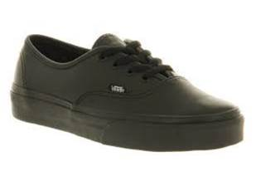

**Final judgement regarding acceptability will always rest with the Senior Leadership Team and Guidance Managers**

